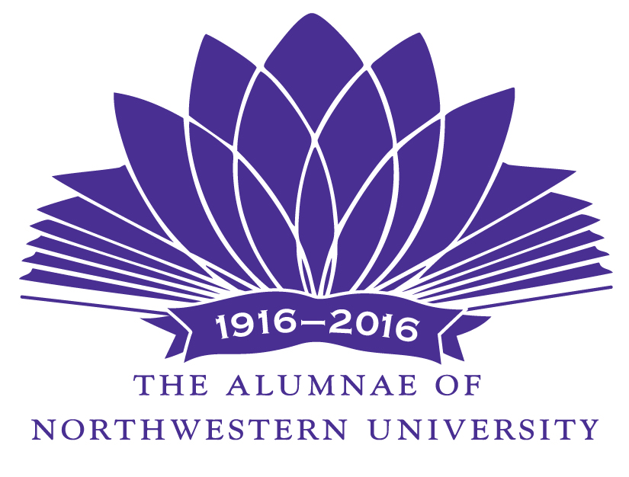

The Alumnae of Northwestern University invites you to be a patron of the 85th Waa-Mu Show.

The Waa-Mu Show 2016
“ANOTHER WAY WEST”

Under the sixth-year direction of award winning Northwestern faculty member, David H. Bell, Waa-Mu 2016 is a showcase for the multi-talented students of Northwestern University. Enjoy a performance presented by the combined schools: Theater and Interpretation Center, School of Communication and Bienen School of Music.

Patron tickets are $50* each, and Patrons receive preferred seating and recognition as Patrons
in the Waa-Mu program.

Enclosed is $_____ for ____ Patron tickets at $50* each.

Make checks payable to Northwestern University and send to: WAA-MU Tickets
233 Sheridan Road
Kenilworth, Il 60043
Friday, April 29 Evening 7:30 p.m.
Saturday, April 30 Evening 7:30 p.m.
Sunday, May 1 Matinee 2:00 p.m.
Thursday, May 5 Evening 7:30 p.m.
Friday, May 6 Evening 7:30 p.m.
Saturday, May 7 Evening 7:30 p.m.
Saturday, May 7 Evening 7:30 p.m.
Sunday, May 8 Matinee 2:00 p.m.

First Choice_____________________________
Second Choice___________________________
Third Choice____________________________
( ) I cannot attend but wish to contribute $____

From:_________________________________________________________________________

Address:______________________________________________________________________

_______________________________________________________________________
City State Zipcode

Phone:___________________________________

Name(s) to appear on the Patron list:

______________________________________________________________________________

Thanks to the continued support of our Patrons, The Alumnae of Northwestern University helps to provide scholarships as well as academic enrichment grants to carefully selected University projects.
We appreciate and count on your support!

*Cost is $28 per ticket-$22 is tax deductible.

