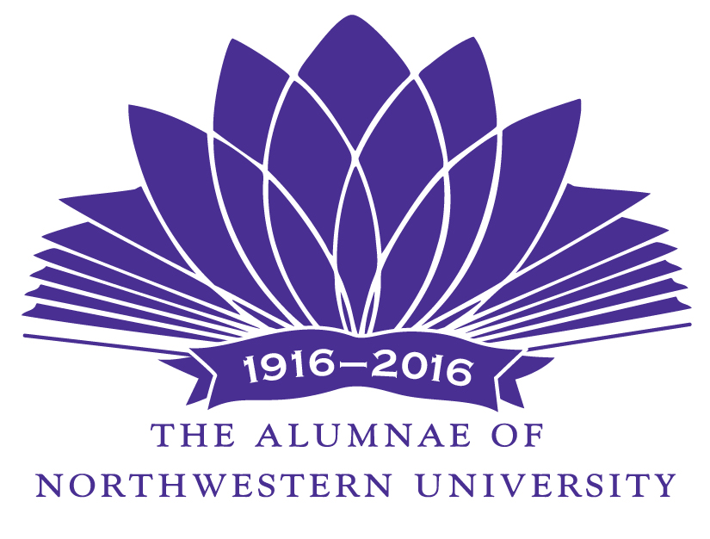

Are you looking for the perfect way to support Northwestern? Want to know exactly how your donation will be used? Select the Alumnae Centennial Endowment for Undergraduate Research!

In celebration of its one-hundred years of volunteer service, The Alumnae of Northwestern University has established a lasting centennial gift for the University. Your club can join in this endeavor and have the opportunity to know directly where your fundraising goes. The Endowment helps individual undergraduates pursue independent research and creative projects now and for years to come.

Alumnae Centennial Endowment for Undergraduate Research

Available to undergraduate students in all academic disciplines, the Endowment will support scholarly projects in the laboratory, the library, and the studio, on campus and around the world, with opportunities to students from all schools and disciplines.

The Endowment will be managed by Northwestern University and awards will be made by the Office of Undergraduate Research. Funds earned by the Endowment will be available for the two programs: the Summer Undergraduate Research Grant and the Undergraduate Research Assistant Program. (See attachment for descriptions.)

“Undergraduate research continues to be one of the top priorities of the University and the amount of students awarded funding through the Office of Undergraduate Research has tripled in less than six years. We are committed to a strictly merit-based review of applications, meaning that the faculty committees select projects that they believe are worthy of funding, likely to succeed, and offer a meaningful experience for the student without regard to cost… Dr. Peter Civetta, Northwestern University Office of Undergraduate Research.

We welcome questions and hope you’ll consider donating to help students today and tomorrow!

Centennial Committee Co-chairs:
Pam James, pam-james@northwestern.edu Anne Martino, annemartino@comcast.net
The Alumnae of Northwestern University, www.nualumnae.org

All donations count toward We Will. The Campaign for Northwestern. For alumni in their Reunion years, individual donations will count towards their Reunion gift.

Programs Supported by the
Alumnae Centennial Endowment for Undergraduate Research

Summer Undergraduate Research Grant (SURG)

SURG’s provide a $3,500 stipend to cover living and research expenses for full-time eight week independent academic and creative work in all fields of study under faculty supervision. Proposals from students are reviewed by a faculty committee from across Northwestern University.

Undergraduate Research Assistant Program (URAP)

The URAP offers Northwestern University faculty the opportunity to hire an undergraduate student to work with them on research or creative projects. The program is designed for the faculty to teach the students the skills needed to later pursue their own independent projects. Applications come from the faculty members. They may apply with a particular student in mind or specify qualifications, and the Office of Undergraduate Research runs a search for a student that matches the qualifications.

For more information about these programs, contact: Office of Undergraduate Research http://www.undergradresearch.northwestern.edu

